PARTENERS WITH SOFZENIX IT SOLUTIONS LLP


Ben8X Digi Marketing Private Limited
ABOUT
At Ben8X Digi Marketing Private Limited, we are driven by a clear vision — to become a leading force in the digital marketing landscape by empowering startups, small businesses, and emerging brands with smart, scalable, and result-oriented marketing solutions. Our mission is to fuel digital growth through strategic services, including Google Ads, SEO optimization, and social media management, designed to deliver measurable impact.
With a strong foundation of expertise, Ben8X Digi Marketing transforms digital ambitions into real success stories. We specialize in building robust social media presences, enhancing online visibility through customized SEO strategies, and running targeted Google Ads campaigns that truly perform. Our approach is simple yet powerful — we listen, understand, and create. By deeply understanding each client’s business, audience, and goals, we develop marketing strategies that are transparent, creative, and data-driven. At Ben8X, we don’t just market — we create pathways for sustainable digital growth.
…………………………………………………………………………………..
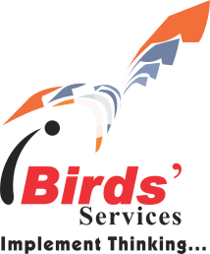
iBirds Software Pvt. Ltd.
ABOUT
iBirds Software Pvt. Ltd. is Salesforce Consulting Partners, and a leading customer-centric Consulting Firm based in India(HQ), with offices across India and US. We have been providing reliable solutions to our clients since 2008, and in this tenure, we have successfully delivered many projects with a more personal and nimble approach unlike other traditional consulting firms. Our top priority is to help you tackle your biggest challenges and turn your vision into reality. We have worked with more than 250+ customers and have included a team of over 170 certified professionals engaged in different projects across continents. With iBirds, it is never just about the project at hand, it’s about building trust and enabling our customer’s long-term benefits. We take utmost care in understanding what you want, involving your people in implementation and support, and share our skills every step of the way to ensure complete success.
…………………………………………………………………


Unlox
Unlox Academy is a modern learning ecosystem built for the future of education. We simplify the learning experience by combining innovation, accessibility, and real-world relevance into a unified platform. Designed to align with evolving industry needs, Unlox enables learners to stay ahead in a world where skills matter more than grades.
to make learning effortless by equipping students with every learning essentials, toolkits and a complete ecosystem to help them achieve their goals with confidence and ease.
Unlox envisions a futuristic student society filled with smart, skillful and true knowledge over vast areas of every domain. Our goal is to empower every student to land their dream job with ease.
………………………………………………………………………
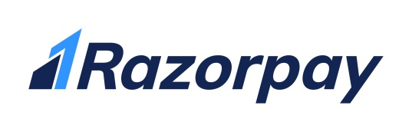
Razorpay

Razorpay is the only payments solution in India that allows businesses to accept, process and disburse payments with its product suite. It gives you access to all payment modes including credit card, debit card, netbanking, UPI and popular wallets including JioMoney, Mobikwik, Airtel Money, FreeCharge, Ola Money and PayZapp.

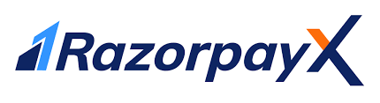
………………………………………………………………………
Razorpay X

RazorpayX supercharges your business banking experience, bringing effectiveness, efficiency, and excellence to all financial processes. With RazorpayX, businesses can get access to fully-functional current accounts, supercharge their payouts and automate payroll compliance.

……………………………………………………………………………………………………..

VETTRIX

Our values are deeply embedded in everything we do and shape the way we work every day. We prioritize quality above all else, striving to deliver only the best results, even if it means starting over to ensure perfection, because subpar work has no place in our standards. Integrity guides our actions; we believe in honesty, transparency, and doing what’s right, both as individuals and as an organization. We also value freedom—the freedom to think creatively, act independently, and demand excellence. Our team has the liberty to choose how they achieve their goals, while our customers have the freedom to expect the best from us. Finally, we believe in teamwork, where collaboration and trust drive success. By sharing responsibilities and leveraging each other’s strengths, we reduce stress and enhance creativity. When strong minds unite with a shared purpose, they truly have the power to change the world.

………………………………………………………………..

Modern Tek
Modern Tek a cutting-edge tech company dedicated to delivering innovative solutions to our clients. Our team of skilled engineers, developers, and designers work tirelessly to create technology that meets the needs of today’s fast-paced and ever-changing world.


………………………………………………………………………………

MARANATHA INNOVATIONS
Maranatha innovations develops and manage a diverse portfolio of products, leveraging advanced technologies and user- centric design to deliver scalable, secure, and impactful solutions across multiple domains.

……………………………………………………………
S3 Hirewise Solutions

S3 Hirewise Solutions, we specialize in connecting top-tier IT talent with leading technology companies. Our mission is to bridge the gap between skilled professionals and organizations seeking innovative solutions. With a deep understanding of the IT landscape, we deliver tailored staffing and recruiting services to meet the evolving needs of the tech industry.
……………………………………………………………

